**SMART HOME WATER TANK SYSTEM USING ESP32**

# A PROJECT REPORT

***submitted by***

**RAMANUJAN N R (210701206)**

**RAMKEERTHAN M A (210701207)**

***in partial fulfillment for the award of the degree of***

# BACHELOR OF ENGINEERING

***in***

## COMPUTER SCIENCE AND ENGINEERING



**RAJALAKSHMI ENGINEERING COLLEGE,**

# ANNA UNIVERSITY : CHENNAI 600 025

**MAY 2024**

# RAJALAKSHMI ENGINEERING COLLEGE, CHENNAI

## BONAFIDE CERTIFICATE

### Certified that this project report titled “SMART HOME WATER TANK SYSTEM” is the bonafide work of RAMANUJAN N R (210701206) RAMKEERTHAN M A (210701207)” who carried out the work under my supervision. Certified further that to the best of my knowledge the work reported herein does not form part of any other thesis or dissertation on the basis of which a degree or award was conferred on an earlier occasion on this or any other candidate.

**SIGNATURE**

### Mrs.Anitha Ashishdeep,M.E.,M.Tech

### SUPERVISOR

Assistant Professor

Department of Computer Science and Engineering

Rajalakshmi Engineering College

Chennai - 602 105

Submitted to Project Viva-Voce Examination held on

**Internal Examiner External Examiner**

## ABSTRACT

This project entails the development of an IoT-based home water tank management system designed to automate the process of monitoring and refilling water tanks. Utilizing an ESP32 DevKit microcontroller as the core processing unit, the system employs an ultrasonic sensor to continuously measure the water level within the tank. The motor, which is controlled via a double-channel relay, is activated or deactivated based on the water level readings, ensuring the tank maintains an optimal fill level. A 15W battery provides power to the system components, including the ESP32, sensor, and relay. The integration with the Blynk IoT application enables remote monitoring and control, allowing users to view real-time water levels and manage the motor operation through a user-friendly mobile interface. This system not only enhances the efficiency and convenience of water tank management but also contributes to water conservation by preventing overflows and ensuring timely refills. The implementation of this project demonstrates the practical application of IoT technologies in everyday household management systems, showcasing the potential for increased automation and smart home integration.

## ACKNOWLEDGEMENT

First, we thank the almighty God for the successful completion of the project. Our sincere thanks to our chairman **Mr. S. Meganathan, B.E., F.I.E.,** for his sincere endeavor in educating us in his premier institution. We would like to express our deep gratitude to our beloved Chairperson **Dr. Thangam Meganathan, Ph.D.,** for her enthusiastic motivation which inspired us a lot in completing this project, and Vice-Chairman **Mr. Abhay Shankar Meganthan**, **B.E., M.S.,** for providing us with the requisite infrastructure. We also express our sincere gratitude to our college principal, **Dr.S.N.Murugesan M.E., PhD.,** and **Dr. P. Kumar M.E., Ph.D., Head of the Department of Computer Science and Engineering,** and our project guide **Ms. Anitha,** for her encouragement and guiding us throughout the project. We would like to thank our parents, friends, all faculty members, and supporting staff for their direct and indirect involvement in the successful completion of the project for their encouragement and support.

### TABLE OF CONTENTS

|  |  |  |
| --- | --- | --- |
| **CHAPT**  **ER No.** | **TITLE** | **PAGE No.** |
|  | **ABSTRACT** | **iii** |
| **1.** | **INTRODUCTION** | **1** |
|  | 1.1 Motivation | **1** |
|  | 1.2 Objectives | **2** |
| **2.** | **LITERATURE REVIEW** | **3** |
|  | 2.1 Existing System | **4** |
|  | 2.1.1 Advantages of the existing system | **4** |
|  | 2.1.2 Drawbacks of the existing system | **4** |
|  | 2.2 Proposed system | **5** |
|  | 2.2.1 Advantages of the proposed system | **5** |
| **3.** | **SYSTEM DESIGN** | **6** |
|  | 3.1 Development Environment | **6** |
|  | 3.1.1 Hardware Requirements | **6** |
|  | 3.1.2 Software Requirements | **8** |
| **4.** | **PROJECT DESCRIPTION** | **8** |
|  | 4.1 System Architecture | **8** |
|  | 4.2 Methodologies | **9** |
| **5.** | **RESULTS AND DISCUSSION** | **10** |
| **6.** | **CONCLUSION AND FUTURE WORK** | **11** |
|  | 6.1 Conclusion | **11** |
|  | 6.2 Future Work | **11** |
|  | **APPENDIX** | **12** |
|  | **REFERENCES** | **16** |

**CHAPTER 1**

### INTRODUCTION

Efficient water management is vital for households, especially in areas with water scarcity or irregular supply. Traditional manual methods of monitoring and refilling water tanks are often inefficient, leading to problems such as overflows or running out of water. To address these issues, this project introduces an IoT-based home water tank management system that automates the process, ensuring optimal water levels with minimal human intervention. At the heart of the system is the ESP32 DevKit microcontroller, selected for its powerful processing capabilities and built-in Wi-Fi, which facilitates seamless integration with the Blynk IoT platform. An ultrasonic sensor is used to continuously measure the water level in the tank, providing real-time data to the ESP32. The microcontroller processes this data to determine if the water level is below a specified threshold. When the water level drops below the threshold, the ESP32 sends a signal to a double-channel relay to activate the motor. The motor then pumps water into the tank until the desired level is achieved. The system is powered by a 15W battery, ensuring uninterrupted operation even during power outages. Connections between the components are made using jumper wires, and tubes are employed to transfer water from the source to the tank. The Blynk IoT app integration allows users to remotely monitor the water level and control the motor through a user-friendly interface on their smartphones. This remote access capability not only enhances convenience but also promotes better water management practices by providing timely alerts and control options. This project demonstrates the practical application of IoT technology in improving everyday household systems. By automating the water tank management process, it provides a reliable solution to common water management challenges, promoting efficiency, conservation, and convenience in domestic settings. The system's design ensures that it is both cost-effective and easy to implement, making it accessible for a wide range of users looking to modernize their home water management practices.

#### 1.2 Objectives

**- **Real-time Water Level Monitoring**:** To utilize an ultrasonic sensor for continuous, real-time measurement of the water level in the tank, ensuring accurate and timely data collection for system operation.

**- **Integration of IoT Technology**:** To implement IoT technologies, specifically the ESP32 DevKit and the Blynk IoT platform, for seamless monitoring and control of the water tank system via a user-friendly mobile application.

**- **Remote Accessibility and Control**:** To enable remote monitoring and control of the water tank system through the Blynk IoT app, providing users with the convenience of managing water levels and motor operation from their smartphones.

**- **Enhancing Water Conservation**:** To promote water conservation by automating the refilling process, ensuring that water is only pumped when necessary, thereby preventing wastage and optimizing water usage.

**- **Scalability and Customization**:** To design the system in a way that it can be easily scaled or customized for different tank sizes and household needs, offering a flexible solution for various water management scenarios..

**CHAPTER 2**

### LITERATURE REVIEW

**1 Automated Plant Watering System**. Abhishek Gupta[1] et al. explain that the system consists of a soil moisture sensor, a water pump, and a microcontroller that controls the watering process. The article also discusses the advantages of using an automated system over manual watering, such as improved plant growth and reduced water waste. Overall, the article presents a useful solution for individuals who want to maintain healthy plants while minimizing their water usage.

**2 Automated Plant Watering System.** K.Ajay Reddy[2] et al. This project provides a user friendly, reliable and automated water pumping system at fields. Now a day’s technology is running with time, it completely occupied the life style of human beings. Even though there is such an importance for technology in our routine life there are even people whose life styles are very far to this well-known term technology. So it is our responsibility to design few reliable systems which can be even efficiently used by them. This basic idea gave birth to the project Node MCU based water pump controller at fields using Relay switches. The project mainly aims in designing water management system using soil moisture

**3 Smart Garden Monitoring System Using IoT.** T.Thamaraimanalan[3] et al. They explain that the system collects data on parameters such as temperature, humidity, soil moisture, and light intensity using sensors and sends the data to a cloud-based server for storage and analysis. The article also describes how the system can be accessed remotely through a mobile application. The authors highlight the benefits of such a system, including improved plant growth and reduced water usage, as well as potential applications for large-scale farming. Overall, the article provides a useful resource for individuals interested in implementing an IoT- based garden monitoring system.

**4 Embedded Based Green House Monitoring system using Microcontroller.** Arul Jai Singh [4] et al. presents a system designed to monitor and control the environmental parameters of a greenhouse using an embedded system based on a PIC microcontroller. The authors, Arul Jai Singh, Raviram, and Shanthosh Kumar, explain that the system measures parameters such as temperature, humidity, and light intensity using sensors and adjusts them to maintain optimal conditions for plant growth. The article also describes the implementation of a web-based interface for remote monitoring and control of the system. The authors highlight the benefits of the system, including increased yield and reduced energy consumption, as well as potential applications in commercial agriculture. Overall, the article provides a useful resource for individuals interested in implementing an embedded-based greenhouse monitoring system for optimal plant growth.

## 2.1 Existing System

Traditional water tank management systems typically rely on manual monitoring and control, requiring individuals to physically check water levels and operate pumps. Some systems use float switches to automate pump activation, but these are often prone to wear and have limited functionality. Advanced systems might include basic electronic controllers, but they generally lack real-time monitoring, remote access, and integration with modern IoT platforms, limiting their efficiency and convenience..

#### 2.2 Proposed System

The proposed IoT-based home water tank management system automates the monitoring and refilling of water tanks using an ESP32 DevKit microcontroller and an ultrasonic sensor. The system continuously measures the water level and controls a motor via a double-channel relay, ensuring the tank is maintained at optimal levels. Powered by a 15W battery, the system guarantees uninterrupted operation. Integration with the Blynk IoT app enables real-time monitoring and remote control, allowing users to manage the water tank efficiently from their smartphones. This approach enhances convenience, promotes water conservation, and offers a scalable, user-friendly solution for modern water management.

#### 2.2.1Advantages of the proposed system

**• **Efficient Water Management**:** The proposed system automates water tank monitoring and refilling, optimizing water usage and preventing wastage through accurate, real-time control of the motor. This promotes water conservation and ensures that the tank is always at the desired level without manual intervention.

**• **Remote Accessibility**:** Integration with the Blynk IoT app enables users to monitor and control the water tank system remotely from their smartphones. This feature provides convenience and flexibility, allowing users to manage water levels and motor operation from anywhere, at any time.

**• **User-friendly Interface**:** The Blynk app provides a simple and intuitive interface for monitoring and controlling the water tank system. Users can easily access important information and adjust settings with just a few taps, enhancing usability and accessibility for individuals of all ages and technical abilities. •

**CHAPTER 3**

#### SYSTEM DESIGN

##### 3.1 Development Environment

###### 3.1.1 Hardware Requirements

##### 1. ESP32 Board

##### 2. Ultra Sonic Sensor – HC-SR04(Generic)

##### 3. Double Channel Relay Module- 5V Relay Module

##### 4. DC Motor Pump- 5V Water Pump

##### 5. Bread Board and Jumper cables

##### UltraSonic Sensor Module

The ultrasonic sensor is used to measure the water level in the tank by emitting sound waves and calculating the time it takes for the echo to return. This real-time data is sent to the ESP32 microcontroller, enabling accurate monitoring of water levels. Its precise measurements ensure efficient and automated control of the tank's filling process.

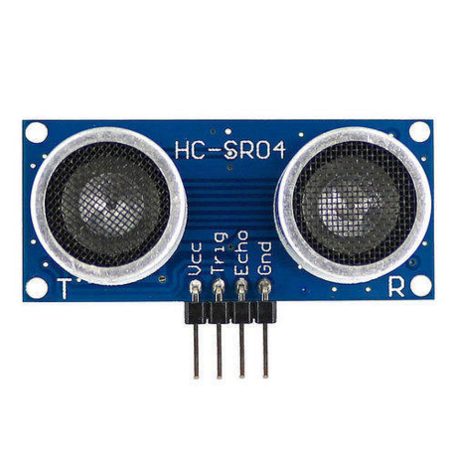

Fig.3.1 UltraSonic Sensor

##### ESP32 WiFi Development Board

A low-cost microcontroller with built-in Wi-Fi capability. This will act as the main controller and handle data processing and communication.

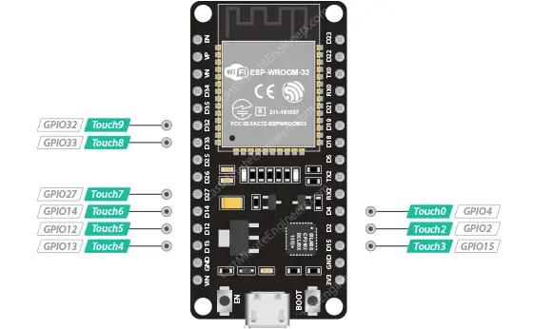

Fig.3.2 ESP32 Module

##### Submersible motor

##### The power source for these small, lightweight submersible pump motor ranges from 2.5 to 6V. It uses just 220 mA of electricity and has a maximum flow rate of 120 liters per hour. All that is required is to connect a tube pipe to the motor output, submerge it, and then power it. Never allow the motor to submerge underwater.

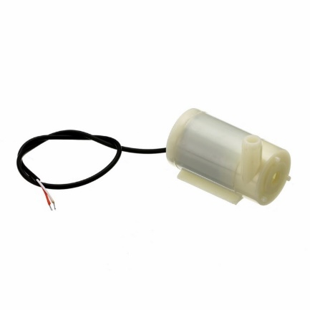

Fig.3.3 Submersbile Motor

**Relay module**

A power relay component is an electronic switch that can handle on an electromagnet

. The electromagnet is switched on by a divide small power signal that is sent by a

microcontroller. Once it started, the electromagnet stated to either open or close an

electrical circuit

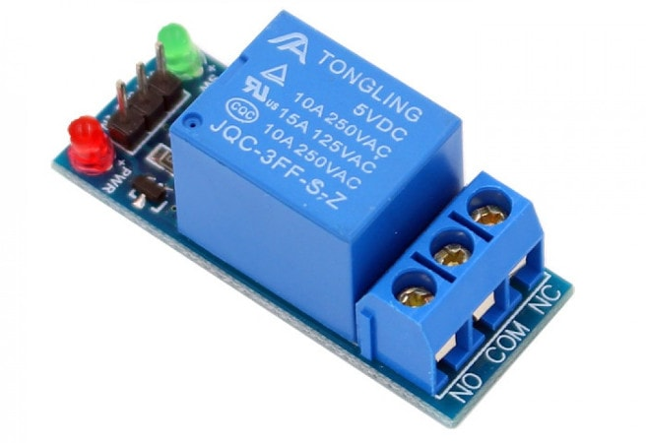

Fig.3.4 Relay

##### Jumper Wires

Male-to-male and male-to-female jumper wires are needed for making connections between the ESP32, MPU6050, and the breadboard.

##### BreadBoard

A breadboard is used for prototyping and making temporary connections between the components without soldering.

##### USB Cable

A USB cable (Micro-USB to USB) is required to power the ESP32 and upload the code from the computer.

##### 3.3V Power Supply

The ESP32 development board and the MPU6050 sensor module require a stable

3.3V power supply for operation.

###### 3.1.1Software Requirements

* **Arduino IDE:** Used for programming the ESP32 with firmware code.

* **Blynk App:** Download and install the Blynk app on your smartphone. Blynk provides both Android and iOS versions, so choose the appropriate one for your device.
* **Blynk Library for Arduino**: Install the Blynk library in the Arduino IDE. This library allows communication between the ESP32 board and the Blynk app.

You can install the Blynk library through the Arduino Library Manager.

**CHAPTER 4**

#### PROJECT DESCRIPTION

The IoT-based home water tank management system automates the monitoring and refilling process to ensure optimal water levels with minimal human intervention. At its core, the system utilizes an ESP32 DevKit microcontroller, an ultrasonic sensor, and a double-channel relay. The ultrasonic sensor continuously measures the water level in the tank, providing real-time data to the ESP32. Based on this data, the microcontroller determines whether the water level is below a predefined threshold. When necessary, the ESP32 activates the motor via the relay to pump water into the tank until the desired level is reached. A 15W battery powers the system, ensuring uninterrupted operation even during power outages. The integration with the Blynk IoT app allows users to remotely monitor the water level and control the motor from their smartphones. This system offers several advantages over traditional manual methods, including improved water management efficiency, remote accessibility, and timely alerts. By automating the water tank management process, it promotes water conservation and reduces the risk of overflows or shortages. The user-friendly interface of the Blynk app makes it easy for users to monitor water levels, adjust settings, and receive alerts, enhancing convenience and usability for individuals of all technical abilities. Overall, this project demonstrates the practical application of IoT technology in enhancing everyday household systems. By providing a reliable and efficient solution to common water management challenges, it contributes to improved water conservation practices and offers a scalable and customizable solution for modern home water management needs.

##### 4.1 SYSTEM ARCHITECTURE

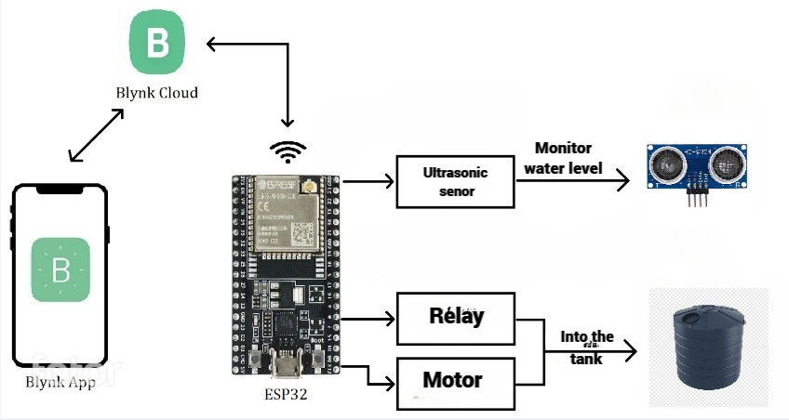

#### Fig 4.1 System Architecture

##### 4.2 METHODOLOGY

1. **Hardware Setup**: Connecting the ESP32 DevKit, ultrasonic sensor, double-channel relay, and motor.

2. **Software Development:** Programming the ESP32 to read sensor data, control the relay based on water level thresholds, and integrate with the Blynk app.

3. **Testing:** Validating system functionality, including water level measurement accuracy, motor control, and remote monitoring via the Blynk app.

4. **Deployment:** Installing the system in the desired location and ensuring seamless operation in real-world conditions..

**CHAPTER 5**

#### RESULTS AND DISCUSSION

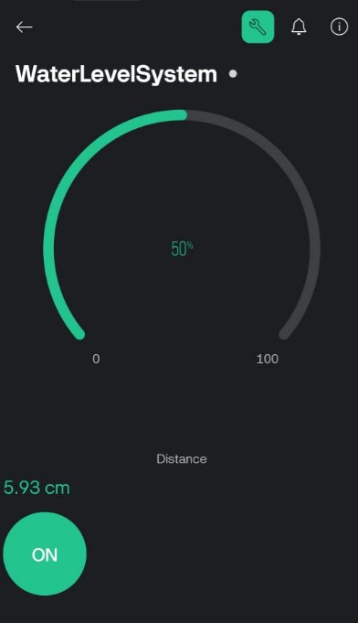

The above picture shows the real time results on Blynk App web dashboard Screen.it displays the Exact Water Level Percentage of the tank. The Blynk application is connected to Wi- Fi. Through this Wi-Fi the App can shows the Readings in any Android Device

**Fig -5.**1: Interface of Blynk Application

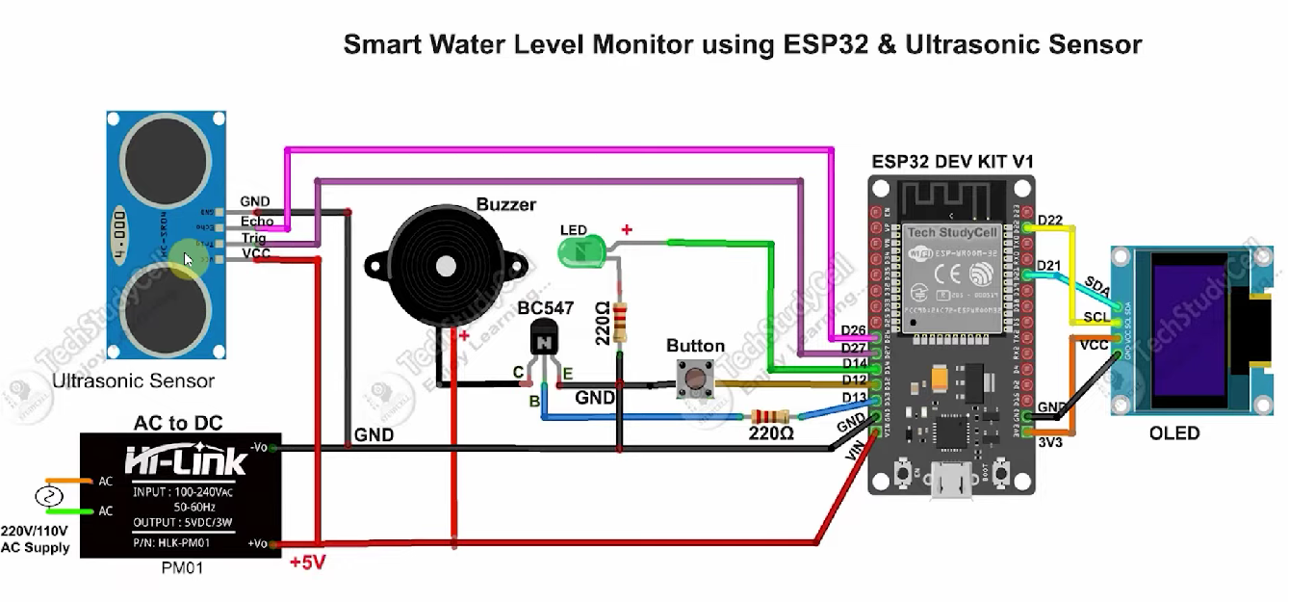

**Fig -5.2:** Circuit diagram.

**CHAPTER 6**

#### CONCLUSION AND FUTURE WORK

##### 6.1 Conclusion

In conclusion, the IoT-based home water tank management system offers an efficient and convenient solution for monitoring and refilling water tanks. By automating the process and integrating with the Blynk IoT app, the system ensures optimal water levels while promoting water conservation and reducing manual effort. The user-friendly interface enhances accessibility for users of all technical backgrounds, while real-time alerts enable timely intervention in case of anomalies. Overall, this project demonstrates the practical application of IoT technology in improving everyday household systems, contributing to sustainability efforts, and enhancing quality of life through modernized water management practices.

##### 6.2 Future Work

**1. Advanced Monitoring:** Integrating additional sensors for monitoring water quality, temperature, and other parameters to provide comprehensive insights into water management.

**2.Machine Learning Integration:** Implementing machine learning algorithms to analyze data patterns and optimize water usage based on historical usage and environmental factors.

**3.Smart Leakage Detection:** Developing algorithms to detect and alert users about potential leakages in the water tank or distribution system, enhancing water conservation efforts.

**4.Integration with Smart Home Systems:** Integrating the water tank management system with other smart home devices for seamless automation and enhanced user experience..

**APPENDIX**

**SOFTWARE INSTALLATION**

#### Arduino IDE

We need to first install the Arduino IDE, then install the required modules for ESP32. After running the code successfully, mount it.

#### Sample code

#define BLYNK_TEMPLATE_ID "TMPL31-BBvpOW"

#define BLYNK_TEMPLATE_NAME "WaterLevelSystem"

#define BLYNK_AUTH_TOKEN "QsH91Fhx61gGBc80PTa85M8fS0fz55_9"

#include <WiFi.h>

#include <WiFiClient.h>

#include <BlynkSimpleEsp32.h>

char auth[] = BLYNK_AUTH_TOKEN;

char ssid[] = "1+ram";

char pass[] = "j4d8qg74";

#define TRIGPIN 27 //D27

#define ECHOPIN 26 //D26

#define wifiLed 2 //D2

#define GreenLed 14 //D14

#define BuzzerPin 22

#define VPIN_BUTTON_1 V1

#define VPIN_BUTTON_2 V2

float duration;

float distance;

int waterLevelPer;

BlynkTimer timer;

void checkBlynkStatus() { // called every 3 seconds by SimpleTimer

bool isconnected = Blynk.connected();

if (isconnected == false) {

//Serial.println("Blynk Not Connected");

digitalWrite(wifiLed, LOW);

}

if (isconnected == true) {

digitalWrite(wifiLed, HIGH);

//Serial.println("Blynk Connected");

}

}

BLYNK_CONNECTED() {

Blynk.syncVirtual(VPIN_BUTTON_1);

Blynk.syncVirtual(VPIN_BUTTON_2);

}

void measureDistance(){

int fullTankDistance = 12;

// Set the trigger pin LOW for 2uS

digitalWrite(TRIGPIN, LOW);

delayMicroseconds(2);

// Set the trigger pin HIGH for 20us to send pulse

digitalWrite(TRIGPIN, HIGH);

delayMicroseconds(20);

// Return the trigger pin to LOW

digitalWrite(TRIGPIN, LOW);

// Measure the width of the incoming pulse

duration = pulseIn(ECHOPIN, HIGH);

// Determine distance from duration

// Use 343 metres per second as speed of sound

// Divide by 1000 as we want millimeters

distance = ((duration / 2) * 0.343)/10;

waterLevelPer = 100-(distance/fullTankDistance)*100;

Blynk.virtualWrite(VPIN_BUTTON_1, waterLevelPer);

Blynk.virtualWrite(VPIN_BUTTON_2, (String(distance) + " cm"));

if(waterLevelPer>70){

digitalWrite(GreenLed, HIGH);

}

else if (waterLevelPer<20){

digitalWrite(GreenLed, LOW);

}

delay(100);

}

void setup() {

Serial.begin(9600);

pinMode(ECHOPIN, INPUT);

pinMode(TRIGPIN, OUTPUT);

pinMode(wifiLed, OUTPUT);

pinMode(GreenLed, OUTPUT);

pinMode(BuzzerPin, OUTPUT);

digitalWrite(wifiLed, LOW);

digitalWrite(GreenLed, HIGH);

delay(10);

Serial.print("Connecting to ");

Serial.println(ssid);

WiFi.begin(ssid, pass);

int wifi_ctr = 0;

while (WiFi.status() != WL_CONNECTED) {

delay(500);

Serial.print(".");

}

if(WiFi.status()==WL_CONNECTED){

Serial.print("Helo");

}

timer.setInterval(2000L, checkBlynkStatus);

Serial.println("WiFi connected");

Blynk.begin(auth, ssid, pass);

}

void loop(){

measureDistance();

Blynk.run();

timer.run();

}

#### REFERENCES

1. Y ] Abhishek Gupta, Shailesh Kumawat, Shubham Garg, **"Water level sensing System"**, Vol-2, Issue-4, 2016 ISSN: 2454 - 1362..

1. Taylor Francis Group, **"Automated Plant Watering System", LLC, pp.59-69, 16 September 2016.Taylor Francis Group,"**Automated Plant Watering System", LLC, pp.59-69, 16 September 2016...
2. T.Thamaraimanalan , S.P.Vivekk ,G.Satheeshkumar, P.Saravanan,**"Smart HOME System Using IOT"**,IEEE,pp.5- 10,2018.
3. Arul Jai Singh, Raviram, Shanthosh Kumar, **"Embedded Smart House Monitoring system using pic Microcontroller"**, IEEE Trans. Syst, Man, Cybern. Systems and Humans, vol. 41, no. 6, pp.1064-1076, November 2011.